UDC (10 pt, size 10, aligned to the left)

FIRST NAME SURNAME (Times New Roman, size 10, centered, uppercase letters, one)

THE TITLE (Times New Roman, size 10, uppercase letters, bold, centered)

Abstract in Belarusian/Russian (size 9, first-line indent 0.8 cm, justified)

The main text: (size 10, first-line indent 0.8 cm, justified
Math equations (MathType).The length <= 110 mm.

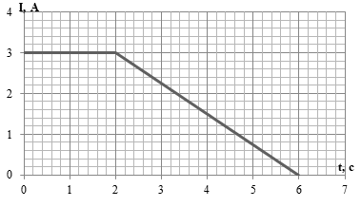

Figyre 1 –Time dependence of the current.
Size 9, first-line indent 0.8 cm, centered

References

1. (size 9, first-line indent 0.8 cm, justified)
2. Ivanova, K. Structure and Properties of Tantalum Coatings / K. Ivanova, G. Shapochkin // Applied Sciences. – 2020. – Vol. 10, iss. 11. – P. 1-12.
3. Ivanova, N. Influence of x-ray irradiation on special purpose elastomers / N. Ivanova, G. Shpochkin // Abstract of 7th International Congress on Energy Fluxes and Radiation Effects, Grodno, September 14-26, 2015. P. 479.

Abstract in English.
50-100 words
Ssize 9, first-line indent 0.8 cm, justified.

Acknowledgements, 50-100 words, (size 9, first-line indent 0.8 cm, justified)

Information about authors (authors’ names and surnames, affiliations containing full address, name of the University/Corporation, name of the Institute/Department, street, postal code, city, country, e-mail addresses). Size 9.
Information about authors supervisors (name and surname, affiliation, containing full address, name of the University/Corporation, name of the Institute/Department, street, postal code, city, country, e-mail addresses). Size 9.

